

SIMATS ENGINEERING

Saveetha Institute of Medical and Technical Sciences Chennai- 602105

Student Name: P.PRASANNA SREE Reg. No: 192324309
Course Code: DSA0613 Slot: A
Course Name: Data Handling and Visualization for Data Analytics Course Faculty: Dr. Kumaragurubaran T & Dr. Senthilvadivu S
Project Title: Trend Visualization of Electric Vehicle Adoption for Sustainable Transportation Analysis
Module Photographs: (3 photographs –Module Photo, Individual student contribution module work in the project and presentation image)
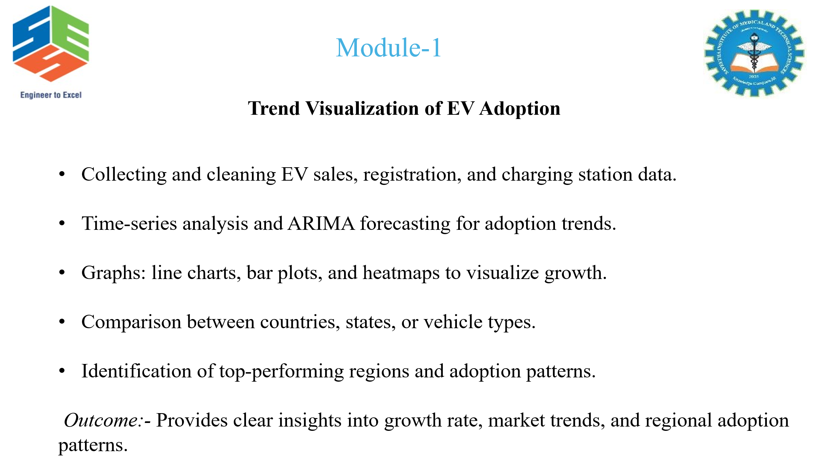
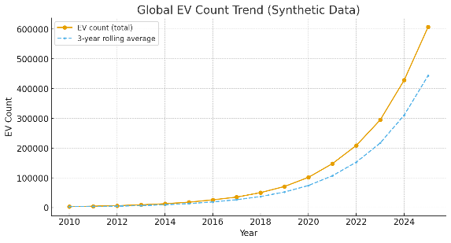
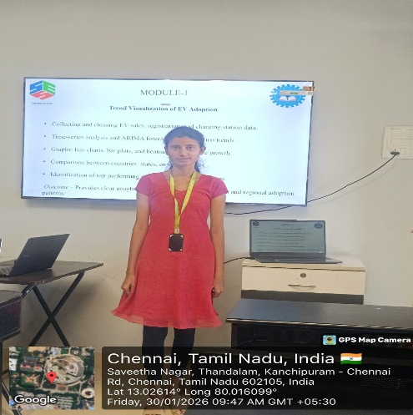
Project Description: Geospatial Population Density Trend Prediction
This module analyzes and visualizes electric vehicle (EV) adoption trends to support sustainable transportation planning. It uses datasets such as vehicle registrations, policy records, charging infrastructure data, and environmental indicators to study EV growth across regions and time periods.
The module involves data preprocessing, temporal and spatial analysis, and visualization using line charts, bar charts, area plots, and maps to highlight adoption trends and regional variations. Basic analytical and forecasting techniques are applied to identify growth patterns and future adoption potential. The outcomes assist policymakers and planners in making informed decisions for sustainable mobility development.

Student Signature Guide Signature

